**THE FEDERAL POLYTECHNIC MUBI**

**P.M.B 35 MUBI NORTH ADMAWA STATE.**

**TECHNICAL REPORT ON STUDENT INDUSTRIAL WORK EXPERIENCE SCHEME (SIWES)**

**AT**

**SAVANNAH SUGAR REFINERY,**

**NUMAN, ADAMAWA STATE**

**BY**

**GABRIEL MATTHIAS ZULI**

**ET/EE/ND/21/048**

**ELECTRICAL AND ELECTRONICS ENGINEERING TECHNOLOGY DEPARTMENT**

**A REPORT PRESENTED TO THE DEPARTMENT OF ELECTRICAL ELECTRONICS ENGINEERING TECHNOLOGY AS A PARTIAL REQUIREMENT FOR THE AWARD OF NATIONAL DIPLOMA (ND) IN ELECTRICAL AND ELECTRONICS ENGINEERING TECHNOLOGY**

**AUGUST, 202****3**

# DEDICATION

I dedicate this Technical report to Almighty God, who guided and protected me throughout the period of my Industrial Training. I also, dedicate this work to my lovely mother and father who gave me the sound moral upbringing. Thank you, may the Lord God, king of glory reward you all. Amen.

# ACKWOLEDGEMENTS

I wish to register my profound gratitude to God Almighty for the guidance and grace throughout my life.

I’m grateful to the entire staff of Savannah Sugar Refinery, Numan, AdamawaState for making my industrial training interesting, educative and worthwhile.

My special gratitude goes to my Head of Department Engr. Victor Nkeleme for his effort to see that this work saw the light of day. I appreciate all my amazing lecturers in the department, my wonderful SIWES coordinator Engr. Abdulhamid Mohammed for his guidance throughout the SIWES exercise, my supervisor.

My regards to my amazing parents Mr. and Mrs. Mathias Madubu Zuli and my lovely brothers and sisters and my wonderful Aunty who has supported me morally and financially and also spiritually to see my success come through, I love you all. I pray may Almighty God reward you all in any area you have rendered assistance on me.

I am greatly indebted to my co-SIWES students to mention, may God strengthen our relationship together and grant us academic excellence.

**TABLE OF CONTENTS**

Title page - - - - - - - - - i

Dedication - - - - - - - - - ii

Acknowledgement - - - - - - - - iii

Table of contents

Abstract - - - - - - - - - vi

**Chapter one**

Introduction - - - - - - - - - 1

Background of siwes - - - - - - - 1

Aims and objectives of siwes - - - - - - 2

Brief historical background of yedc - - - - - 3

Company aims and objectives - - - - - - 3

Organizational structure - - - - - - - 3

Organizational chart - - - - - - - - 4

**Chapter two**

Fault section - - - - - - - - - 5

Definition of fault - - - - - - - - 5

Instruments used in the fault section - - - - - - 5

Definition of circuit breaker - - - - - - - 6

Definition of fuse - - - - - - - - 7

Maintenance section - - - - - - - - 8

Maintenance of transmission - - - - - - - 11

Maintenance of transformer and sub-station - - - - - 12

**Chapter three**

Distribution line section - - - - - - - 13

Sighting - - - - - - - - - 15

Draw of service (single phase) - - - - - - 15

Disconnection and reconnection - - - - - - 16

Tools used for disconnection and reconnection - - - - 16

Separators - - - - - - - - - 17

Importance of separators - - - - - - - 17

Domestic wiring and insulation - - - - - - 18

**Chapter four**

Conclusion - - - - - - - - - 20

Recommendation - - - - - - - - 20

# ABSTRACT

*This report work provides a look at the key areas I was involved in and the various area I participated in during the period of my attachment, however giving the volume of activities I carry out during the period of these attachment, only major activities are stated. For more description of the various works done during this period the logbook may be consulted for more clarity. This report is divided into five chapters the first and second chapters give the background information about SIWES and the organization was attached while the chapter three and four deals emphatically on the activities done and the experience acquire during the period of my attachment, the last chapter round off the report with conclusion and recommendation*

**CHAPTER ONE**

**1.0 Introduction**

The four months compulsory supervised Industrial attachment is a programme instituted by the Federal Government to help students in their various fields of study.

It is aimed at exposing future graduates to the need or actualization of work situation which must come their way after studies.

Today, our situations of learning are mainly expected to produce graduates that are qualified to meet the demands of manpower by employers of labour in all sectors of the economy.

Before the issue of SIWES came to being, there was a growing concern among industrialists that graduates of higher learning did not pose adequate background studies in preparation for employment in industries and especially in practical aspect. These employers were of the opinion that practical theoretical education going on in the higher institution was respective enough to the need, of employers. Thus, this programme SIWES was designed to supplement theoretical

industries activities in various disciplines.

The objectives of SIWES among others are to expose and prepare students in Engineering and other related courses for technical working situation that may likely face after graduation.

**1.1 Brief history of SIWES**

The Student industrial Work Experience Scheme (SIWES) is a program aimed at exposing students to practical work. If was initially called Industrial Training Fund. (ITF) established by General Yakubu Gowon in the promulgation of Decree No. 47 of Section four (4) in October 1971.

The Federal Government initiated and designed the SIWES as part of the manpower development strategy in 1974. The main aim is to supplement the theoretical method of learning in higher institutions in the country to practical knowledge that is relevant to industrial skills and manpower.

The National headquarters of SIWES is in Jos, Plateau State. If is responsible for the finding and administering of its entire zonal headquarters in all the states of the Federation.

Because of the significance of SIWES, the Federal Polytechnic Mubi in its policy made it mandatory for NDI students of Science and Engineering to undergo Four months Industrial attachment every end of the second semester.

**1.2 Aims and objectives of SIWES**

1. To expose students to work methods and techniques in handling equipment and machines that may not be available in their institutions.
2. To provide an avenue for students in higher institutions to acquire industrial skills and experience in their field of study.
3. To expose students to various rules and regulations as well as policies or industries and other business organizations.
4. To enable students, comprehend some of the problems facing an organization and be able to make some recommendations for the further improvement.
5. To prepare students for work situation, they are likely to meet after graduation.
6. To provide industrialist and other business enterprise with an opportunity to asses and select the caliber of students they would employ after graduation.
7. To enlist and strengthen employers involvement in the entire education process if preparing students future employers

**CHAPTER TWO**

**2.1 Dangote Sugar Company**

The Dangote Sugar Company (D S C) was established I the early 1970s by Federal Government Nigeria. The company was acquired by Dangote Industrials Limited (DIL) from Bureau of public Enterprises (B P E) in 2003 but was official handed over to Dangote Industrial Limited in 2004. It has an installed capacity of 50,000 metric tunes of Sugar; But presently Utilized capacity stands of 29,080 metric tunes of Sugar. Dangote Industrial Limited is sitting on 32,000 hectares of lands in Numan, Adamawa State Nigeria. With about 7,182 heaters presently under cane (planted).

## **2.2 Organizational Chart of Dangote Sugar Company (DSC)**

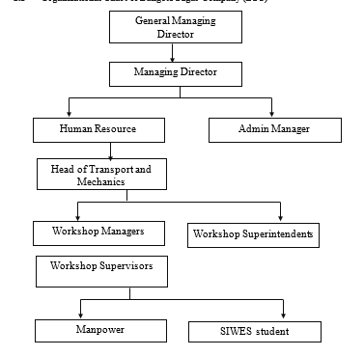

Figure 1: Organizational structure of Dangote Sugar Company.

## **2.3 Measurement using measuring instrument.**

Measurement using multi-meter: measurement is the act or process of observing and reading the observation that are collected as part of a research effort.

A multi-meter is an electronic measuring instrument that combines several measurement functions in one unit. It includes basic features such as the ability to measure voltage, current and resistance.

### ***2.3.1 How to measure using multi-meter***

Black probe should plug into ``com`` socket and red probe into either 300m.A or 20A Socket depending on how the current is, set the switch to symbol A. for alternating current (AC) A with wave-form for direct current (DC) A with straight line symbol. Cut a circuit in one side and connect the probe tips to the circuit that is cut.

### ***2.3.2 Types of multi-meter***

1. Analog multi-meter use a pointer which moves over a scale calibrated for all the different measurement that can be made.
2. Digital multi-meter displayed the measured values in numerical and may also displayed a bar of a length proportional to the quantity being measured.

### ***2.3.3 Voltage measurement using multi-meter***

Black probe to “COM” and red probe to “VΩ” socket, multi-meter switch to symbol (V) with wave line for alternating current (AC) or (V) with straight line for direct current (DC) and the probe tips to the supply to take the measurement.

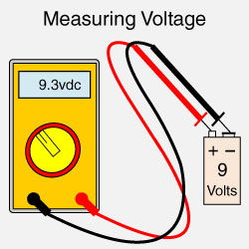

*Figure 2: voltage measurement*

### ***2.3.4 Current measurement using multi-meter***

Black probe should plug into “com” socket and red probe into either “300mA” or 20A socket depending on how the socket is, set the switch to symbol A. For alternating current (AC) with a wave form, for direct current (DC) a straight-line symbol. Cut a circuit in one side and connect the probe tips to the circuit that is cut.

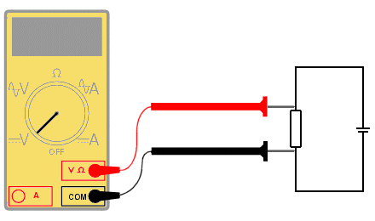

*Figure 3: current measurement*

### ***2.3.5 Resistance measurement using multi-meter***

Black probe to (COM) and red probe to voltage ohm, multi-meter to switch symbol (Ω).

### ***2.3.6 Testing diode using multi-meter***

Black probe to (COM) socket and red probe (VΩ) socket, multi-meter switch to continuity test or ohms (Ω). Looking for forward conductor or reverse conductor of the diode, the probe tips will change their position on the diode for either cathode or anode terminals of the diode.

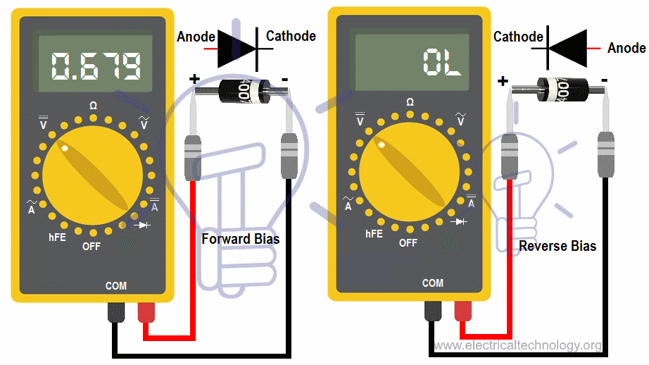

*Figure 4: diode terminal testing*

### ***2.3.7 Testing resistor using Multi-meter***

After plugging the banana jack of the probe to (COM) socket and red probe to (VΩ) socket, multi-meter switch to ohms (Ω) symbol. Finally, both the two probe tips connected to the resistor terminals.

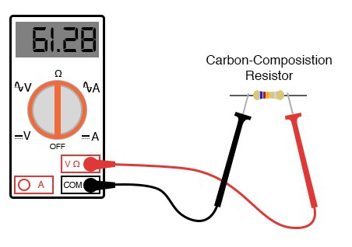

*Figure 5: Resistor testing*

### *2.3.8 Testing capacitor using multi-meter*

Multi-meter switch to (V) symbol. After plugging the banana jack of the black probe to (COM) and red to (Ω) socket, black probe tips connected to negative terminal of the capacitor and red to positive terminal, the multi-meter displayed some values and gradually comes back to zero.

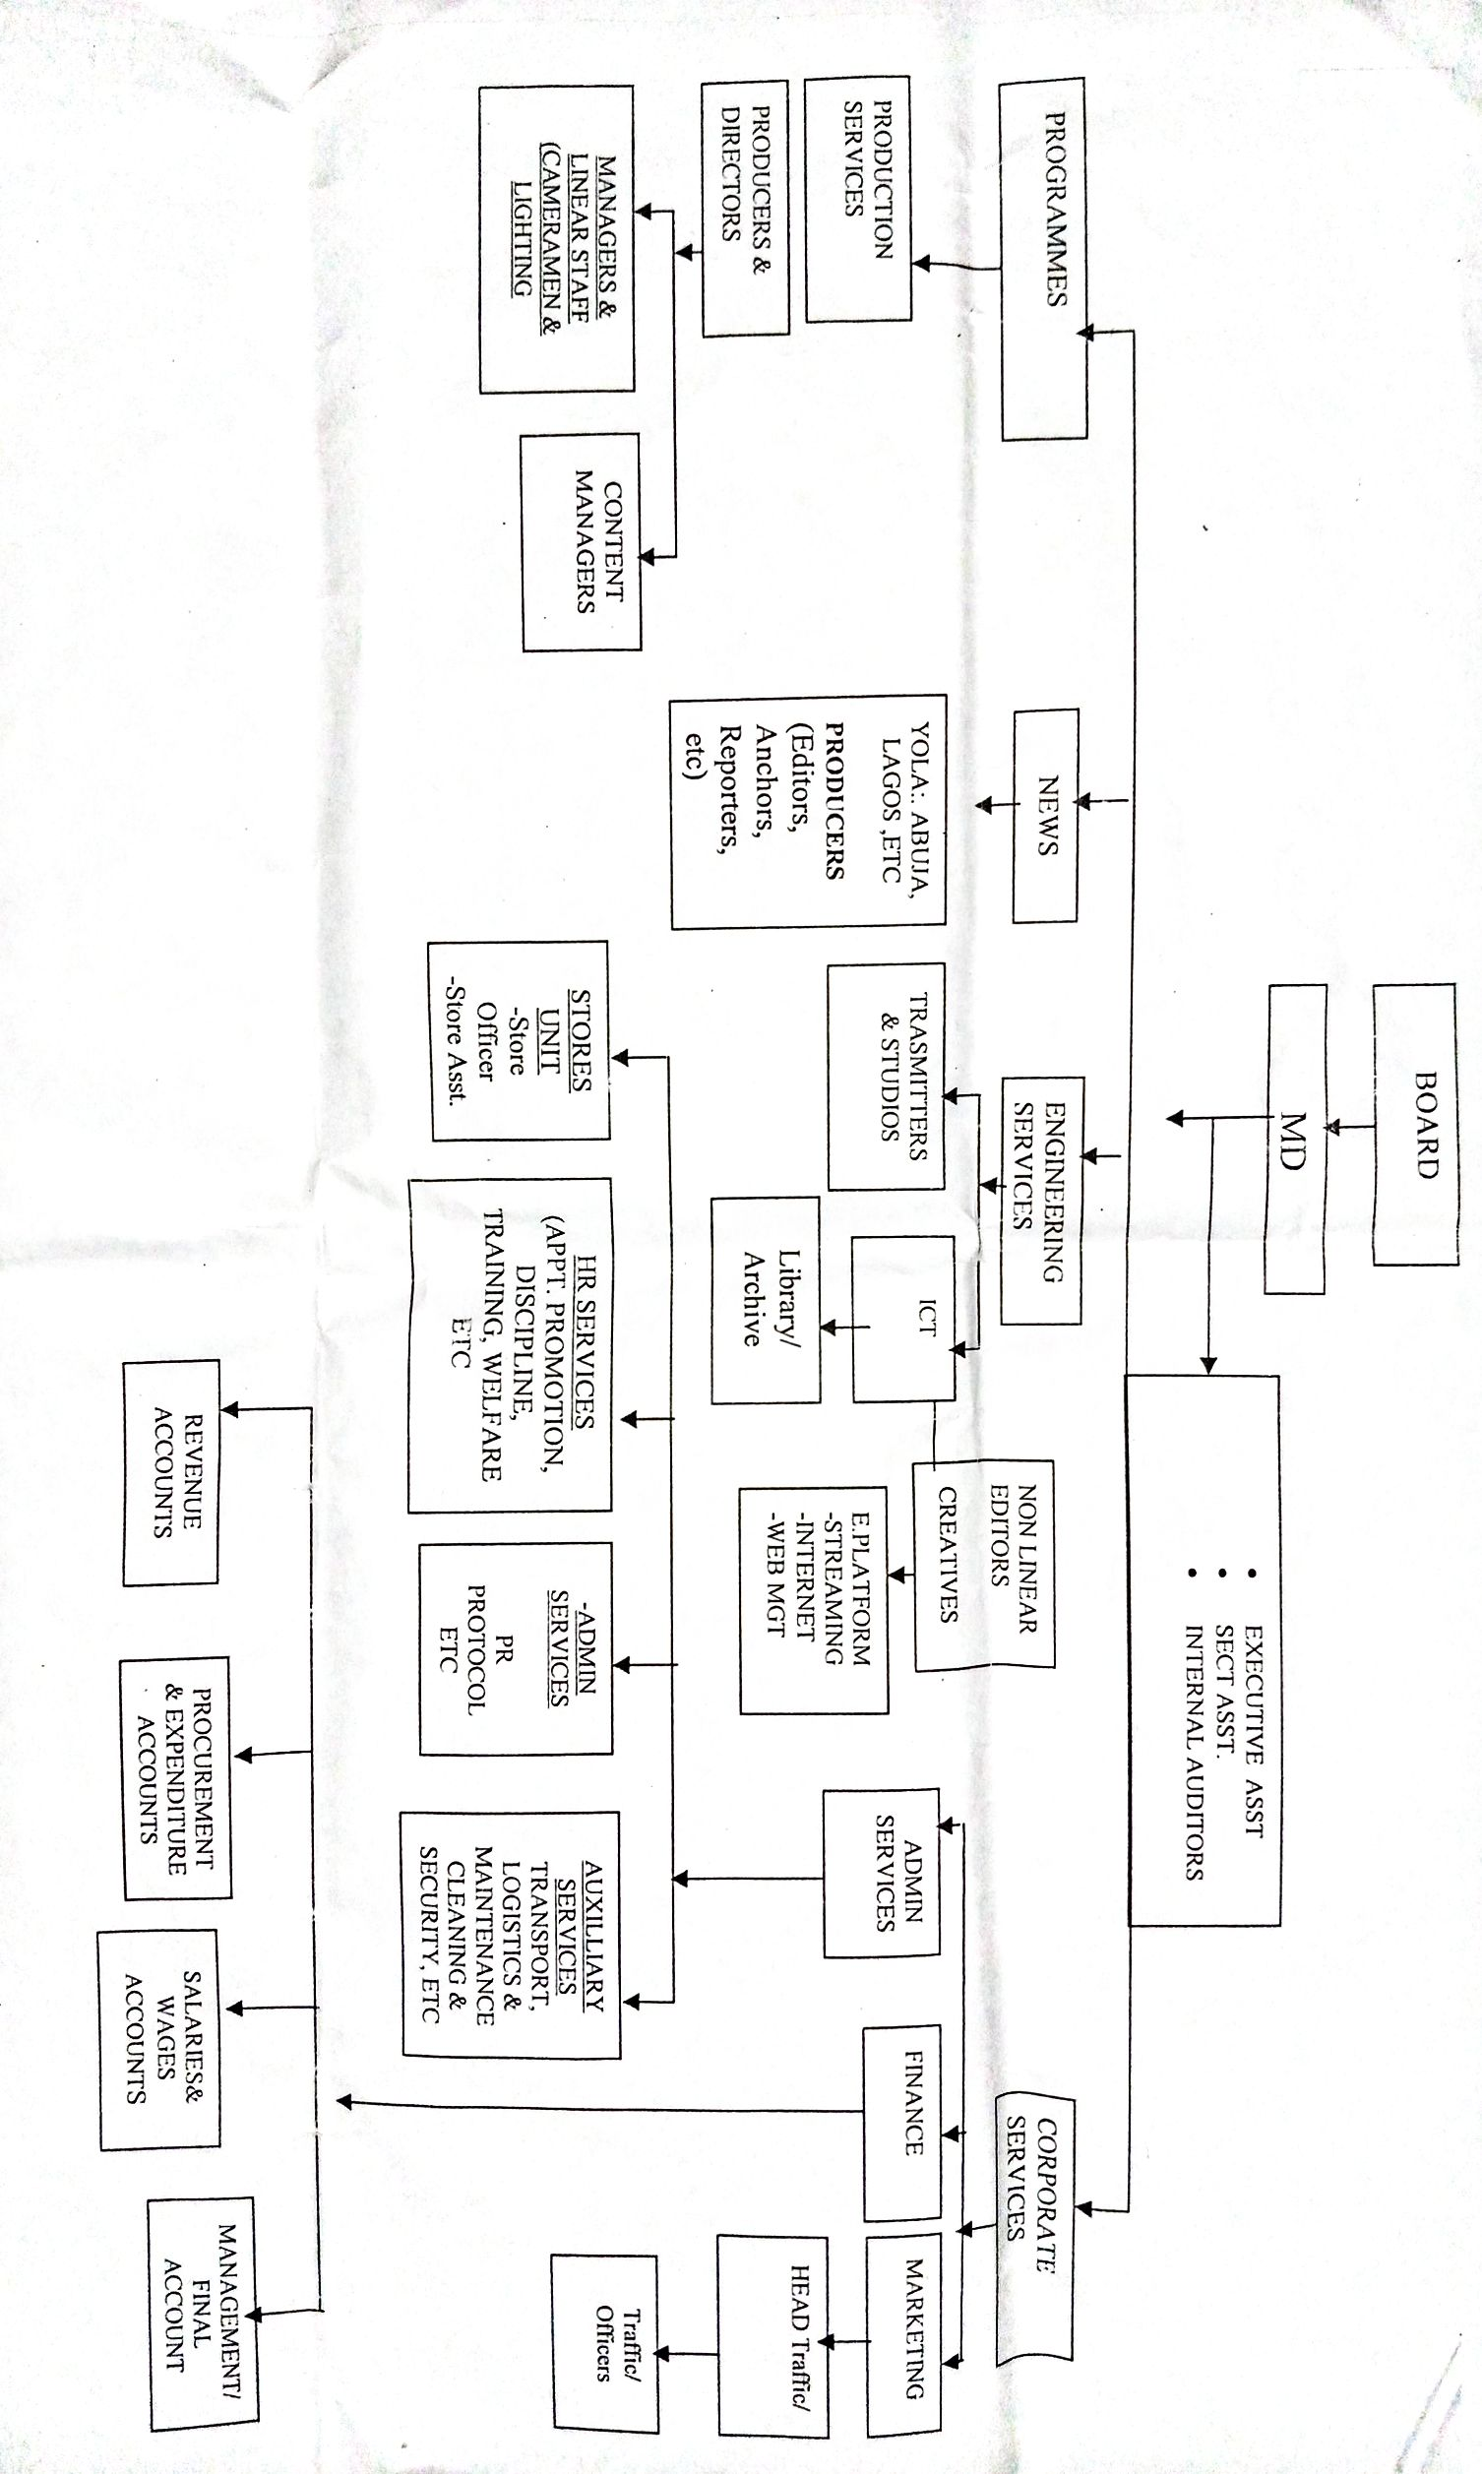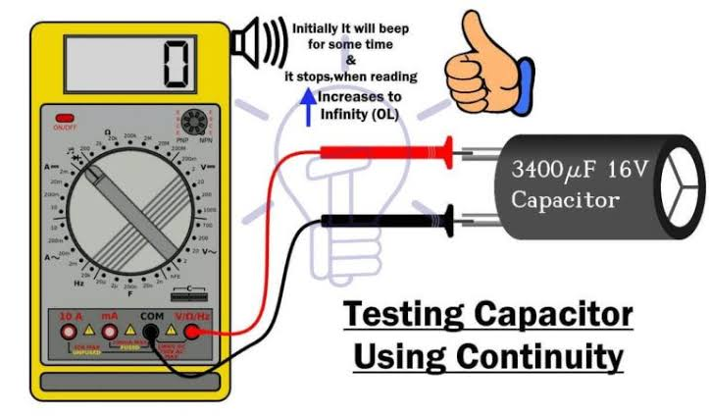

*Figure 6: Capacitor testing*

## **2.4 Identification of an AC and DC motor**

An [AC motor](https://ie.rs-online.com/web/c/automation-control-gear/electric-motors-motor-controllers-peripherals/ac-motors/) is a common type of electric motor, driven by an alternating current. Like the majority of effective practical motors used in everyday industrial applications (as well as in hobbyist projects, domestic goods, and all manner of other professional equipment and consumer products), AC motors offer a relatively efficient method of producing mechanical energy from a simple electrical input signal.

### ***2.4.1 How do AC motors work?***

Conversely, certain [**brushless AC motors**](https://ie.rs-online.com/web/c/automation-control-gear/electric-motors-motor-controllers-peripherals/ac-motors/?applied-dimensions=4294556501) are often given as examples of an induction motor, as the process of generating an alternating charge from an EMF via a rotor and stator is known as (electro)magnetic induction.

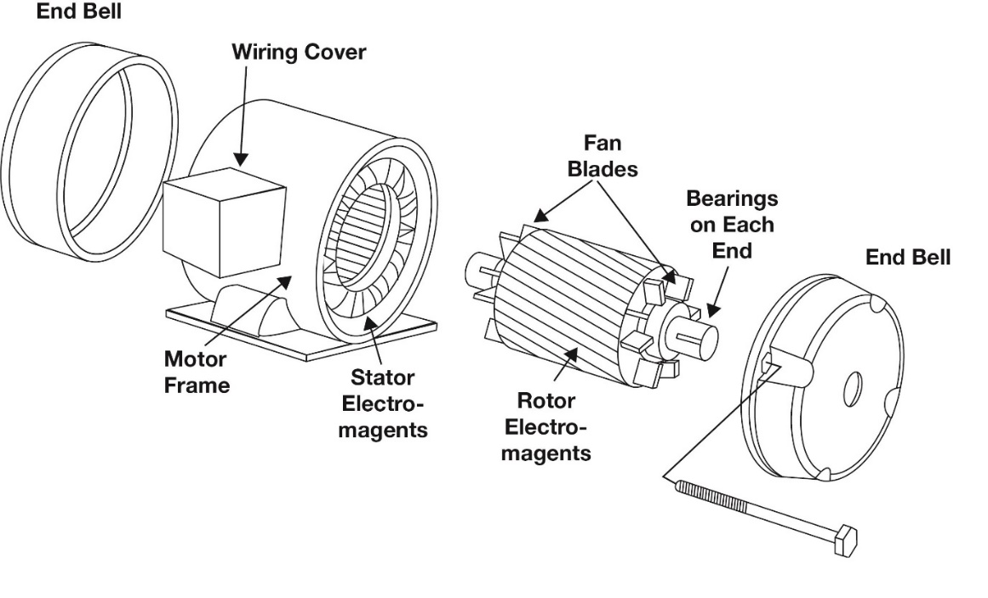

*Figure 7: Parts of an AC motor*

### ***2.4.2 Dismantling a faulty AC motor***

In other to trace the faulty part the motor will be dismantled and carefully wash those parts using diesel to avoid rough and dirty edges.

### ***2.4.3 Assembling or Rearranging an AC motor***

We assembled the already dismantled AC motor in which the AC induction motor was repaired and tested.

**2.5 Fault detection**

They are basically two types of faults

1. Open circuit
2. Short circuit

Open circuit fault is like break of conductor while short circuit fault is like live and live contact (bridging). There are some faults which are basically a fault but they are effective. One or combination of the following effect classified actually electrical fault.

1. Abnormal low-voltage to clear the faulted equipment in circuits
2. Unbalanced current in one various phase

**2.6 Protection (safety) equipment as used in the fault section**

In electricity, the word protection means a system of preventing electrical equipment or components of electrical power from faulty situations, which can destroy the components.

In this section, protection of equipment is the most important aspect. This can be achieved through the electrical connected devices known as:

1. Circuit breakers
2. Fuse
3. Relay

***2.6.1 What is circuit breaker***

A circuit breaker is a mechanical switching device designed to automatically open a circuit under the specified abnormal condition without injury to itself.

**Kind (types) of circuit breakers**

1. Miniature circuit breaker
2. Earth Leakage Circuit breaker

**Miniature Circuit Breaker:** These are manufactured for current rating up to 200amps in medium voltage range. They are better than switch fuse for controlling motors and lightening circuit because of closes overload protection provided by them and more reliable operation. No time is lost as in fuse replacement and there are less chances of single phasing with them.

**Merits of circuit breakers**

1. The fault is easily identified and supply restored.
2. Tripping characteristics is set during manufactured and cannot be altered.
3. Will trip for sustained overload.

***2.6.2 What is a fuse***

A fuse may be defined as a piece of thin metal wire which opens a circuit in which it is inserted by melting when current through it exceeds a certain valve for a sufficient period.

**Kinds of fuse**

1. Cartridge fuse.
2. Re-wireable type and semi-enclosed type.
3. High Breaking Capacity type (HBC).

**Merits of fuse**

1. It is cheap
2. The fuse element can easily be replaced.

**Demerits of fuse**

1. Low rupturing capacity
2. Unreliable operation
3. It is easily damage particularly with short circuit current.
4. Fuse element deteriorated is used

***2.6.3 What is a relay***

A relay is an electrical device which operates when electrical quantities which at respond causes operation in other connected devices. Whenever, such relay is used in protection if equipment, it is called protective relay.

**Use of relay**

1. For protection
2. For control and
3. For regulation

**The function of the protective relay**

1. To detect the presence of fault
2. To identify the faulted component of a system.
3. To initiate tripping in the appropriate circuit breaker.
4. To remove detective component from service.

**Qualities of a good protective relay**

1. Reliability
2. Speed
3. Selectivity

**Reliability**: This is dependability and scheme. Dependability means that the assurance that the relay will operate when security means is needed, the assurance that the relay will not operate if not required to (means when there is no fault).

**Speed**: The speed of a fault clearance is essential since the likelihood of a wide spread system disturbance of complete system collapse, increase with the duration of the faulted equipment to open also minimize the hazard to personnel and may be in the vicinity of work.

**Selectivity**: this means that the protective should accurately identify a system, which is faulted and initiate the tripping off.

**2.7 Maintenance section**

The maintenance section contains about two third of the technical staff of the authority. This is because the existing devices are easier to maintain than to purchase a new one.

Maintenance in the organization is the process of keeping the organization properties in good conditions.

***2.7.1 Need for maintenance***

Maintenance is an important factor in quality and in some cases determines the long-term success of a company. Poorly maintained resources can cause instability and partially or completely pause the production. Malfunctioning machines or complete breakdowns can become a costly process for most company.

***2.7.2 Equipment used in maintenance section***

**Operating Rod:** It is used for making contact with live apparatus, if serves as wire when high tension lines is opening by bridging them.

**Pull Lift:** For lifting heavy devices during work such as transformers, Poles e.t.c. depending on the type of re-tensioning sagged lines.

**Cutlass**: Sometimes there are bridging the conductors, cutlass can be used for the training and cleaning of the transformer substation or any outside the installation place.

***2.7.3 Network (electrical) lines maintenance***

This includes trimming of trees near the distribution lines to avoid being fallen on line which would cause serious fault conditions. That is retention of sagged wire, replacement of broken insulator and stay wires. They also make sure that lines are not over loaded by illegal customers who can just tap their line without informing-the office or the body.

***2.7.4 Maintenance of transmission lines***

A proper designed and erected line will give trouble free service for a long period of time with a little maintenance only.

Regular inspection and corrective action for the defect notice during such inspection will ensure best and successful result.

The following point should be paid particular attention during such inspection.

1. Broken insulators
2. State of Wooden Cross arm
3. Any relative change in the case of difference
4. Drainage conductors
5. Painting
6. The Pole and structure are vertical
7. Accumulation of industrial dirt in poles
8. Tightening the step.
9. Ground clearance over newly constructed embankment works.
10. Watering of earth electrode.

***2.7.5 Maintenance of sub-station transformer***

1. Changing transformer oil
2. Making sure that the temperature of the transformer is kept at minimum level coldness temperature is needed in the transformer.
3. To make sure that all nuts and screws are tightened when necessary.
4. Patching up of any leakage in transformer cylinder.
5. Making sure that earth continuity is effectively placed.

***2.7.6 Feeder pillar (electrical panel)***

The feeder pillar is an outdoor low voltage distributor used in controlling low tension lines. It is a chamber containing cable called the income (i.e. the supply cable) and outgoing cables (the supply out} which we also know as up-riser with dropout fuses protecting them.

And soon other services are replacement of fuses in the feeder retention of cable, replacement of the cross arm, erection of poles, and mounting of insulators.

**Precaution of feeder pillar**

1. Fuse wire of correct rating should be used.
2. Correct fuse wire must be used.
3. Feeder pillar should not be installed in chemically polluted areas.
4. The feeder pillar should have a fence around the place and nobody should go inside.
5. The area of installing the feeder pillar should have a resistance of about 0.02A/m and properly fenced and to ward off unauthorized persons.

**2.8 Planning and construction section (distribution section).**

The planning and construction section is the distribution section; this section is the act of laying down ideas, which will be building with two manners of these materials.

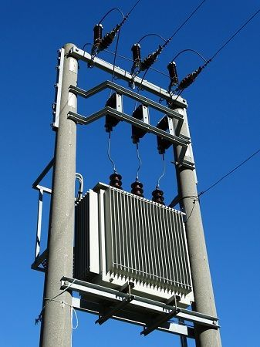

Figure 8: Diagram showing a substation

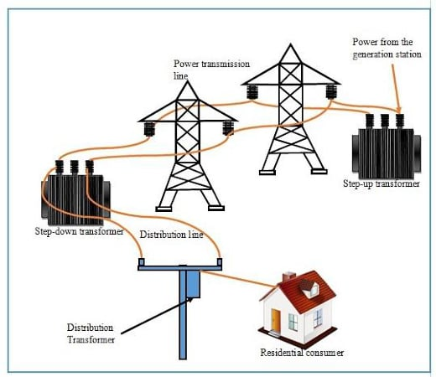

Figure 9: Diagram showing transmission and distribution line

**CHAPTER THREE**

**3.0 Distribution line network section**

Distribution sub-station is dealing with 11kv and 45v. The next important devices found are transformers and feeder pillars. The input is 1 1kv while the output is 415v. I was opportune to work as high- and low-tension distribution lines mainly three phases 415v, when we did erection of poles.

**Procedure of Pole erection**

In Pole erection, first thing to be considered is the site visit whereby sighting, clearing and measurement are made. Digging of holes for pole planting i.e. (415 feet depth) with the help of long shape cables are being drawn one after the other from the red line to the neutral and all the cables are being fixed to the Shackle insulator which was being tightened to the pole.

**3.1 Erection equipment/requirement**

The following are the equipment/requirement for pole planting on the distribution line.

1. Ladder
2. Pole
3. Cable
4. Stay wire
5. Shackle insulator
6. Pulley
7. Hacksaw
8. Extension strip e.t.c.

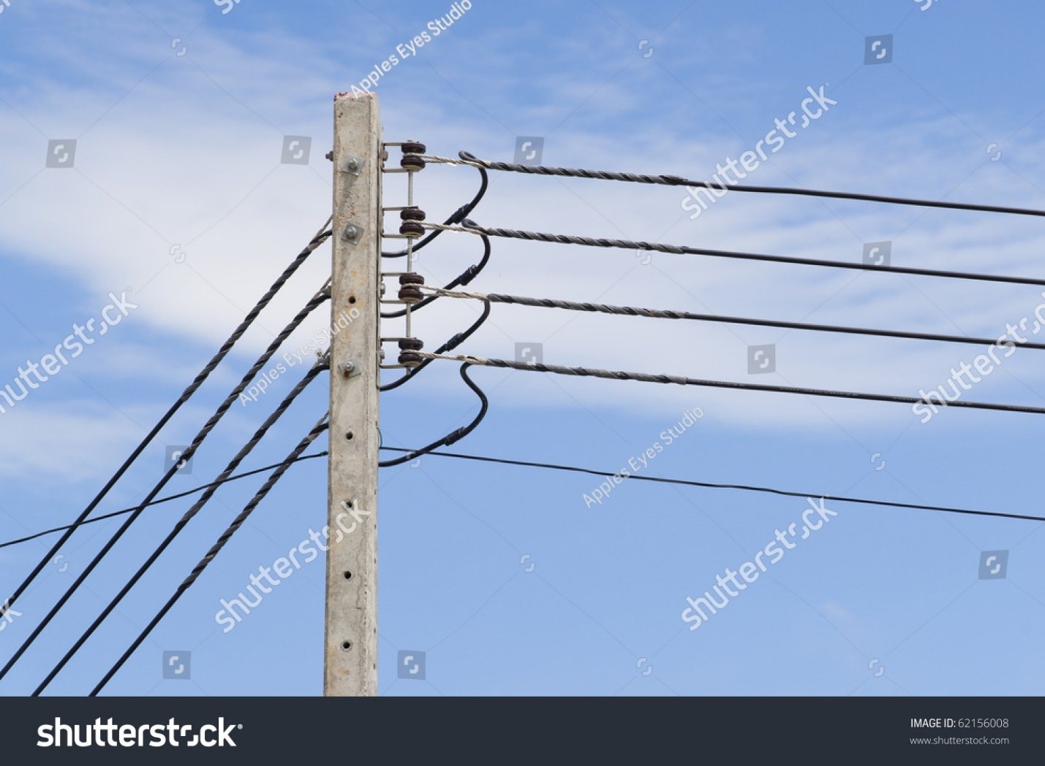

Figure 10: Low Tension Pole

**3.2 Sighting**

Sighting can be described as the first procedure taken on a distribution line by clearing, surveying, measuring and making the site in which production of electric power is to be done.

**3.3 Sighting equipment**

The equipment/requirement during the process of the site includes:

* 1. Spade
  2. Tape rule
  3. Siting rod
  4. Machet/cutlass
  5. Digger
  6. Ranging Pole E.t.c

**3.4 The procedure for erection**

The pole is dug 3½ - 5½ feet. We made sure that all the soil dug was about 60cm away from the hole. Then we drew the pole near to the hole positioning the need to hole tip. We are making sure that the head rest on the tip first before erecting the other end with all hands lighting it. The pole will be erected to 90° up to right. After then, the D-Icon will be fitted and the lines will be drawn. These lines are:

1. Redis phase
2. Yellow is phase
3. Blue is phase.
4. Black is Neutral

**3.5 Draw of service (single phase)**

This is the process whereby the supply is been drawn from low-tension distribution line to the consumers houses. In this aspect, supply is drawn from low tension (LT) with a 18mm2 cable to consumers cutout fuses which is used to protect the meter, it is then passed to the earth leakage circuit breaker (i.e. ELCB)

The purpose of the ELCB is to protect the consumers’ equipment from damage in an event of fault. The supply is then lately passed to the distribution board DB. The distribution board is where all connection of equipment is linked to their various fuse rating.

**3.6 Installation requirement and procedure**

The following are the materials/requirements necessary for carrying out an insulation work on domestic wiring.

1. Screw Driver
2. Stop end
3. Fishing tape
4. Circuit breaker
5. Looping box
6. Pliers: This is for cutting cables
7. Digital insulation tester: For testing the insulation
8. Distribution board.

***3.6.1 Tools that are used***

1. Belt
2. Cutlass: for cutting trees
3. Diggers: for digging holes
4. Shovel: for packing dug soil and digging purposes
5. Drillers: For drilling holes
6. Hacksaw: It is used for cutting tracks, large cables or conduit pipes e.t.c.
7. Hand Gloves: for protecting the hands against any electrical shock.
8. Pull lift: For lifting heavier elevators such as poles, transformers.

**CHAPTER FOUR**

**4.0 CONCLUSION AND RECOMMENDATIONS**

**4.1 Conclusion**

Within the period of industrial training in Savanna Sugar Refinery, Numan, Adamawa State, the knowledge I gathered had made me to know what the Savanna Sugar Refinery, Numan is all about.

In conclusion, I thank Almighty God and Federal Government including NBTE and ITF for making the programme come to reality.

**4.2 Recommendations**

Savanna Sugar Refinery, Numan gave the maximum service by locating fault maintenance by orderly planning and construction to their best electricity power consumer so that life can be made easier.

In summary, if all the protective device and instrumental material are all in good condition, Savanna Sugar Refinery, Numan will make sure that the consumers will be expecting power supply always.

The undertaking office has given adequate support inbuilding up electricity supply to commercial service by the following ways:

1. Safety equipment such as boots, hand gloves, belts, pliers, ladders to ensure good condition of works done.
2. Supply enough fuel to them
3. Providing their functioning vehicles and trucks for conveying some heavy equipment to work place. It also ensured that adequate attention is paid to any fault that may arise.

Fault will be created by using wrong instrument to carry out a job or a fault can be created by appearing on safety equipment that will cause fatal accident.